Assume that an opamp has I_{B1} = 600nA and I_{B2} = 450nA. Determine the Input bias current IB and the offset current IoS.
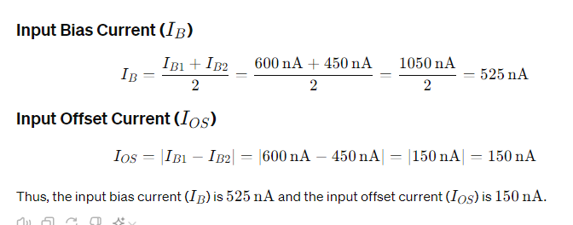
Justify why constant current source is used in differential amplifier.
- A constant current source is used in a differential amplifier to ensure high common-mode rejection ratio (CMRR), which enhances the amplifier's ability to reject noise and interference that is common to both input signals.
- It also stabilizes the operating point of the transistors, ensuring consistent performance.
- Additionally, it provides high impedance, improving the gain and linearity of the differential pair.
List the limitations associated with increasing R_{E} to achieve very high CMRR.
- Increasing \(R_E\) in a differential amplifier to achieve very high common-mode rejection ratio (CMRR) can lead to limitations such as increased power consumption due to higher quiescent current, reduced bandwidth and slew rate due to increased time constants, and decreased input impedance, impacting the amplifier's ability to drive loads efficiently.

Assuming slew rate for 741 is 0.5V/µs, what is the maximum undistorted sine wave that can be obtained for a. 12 V peak.
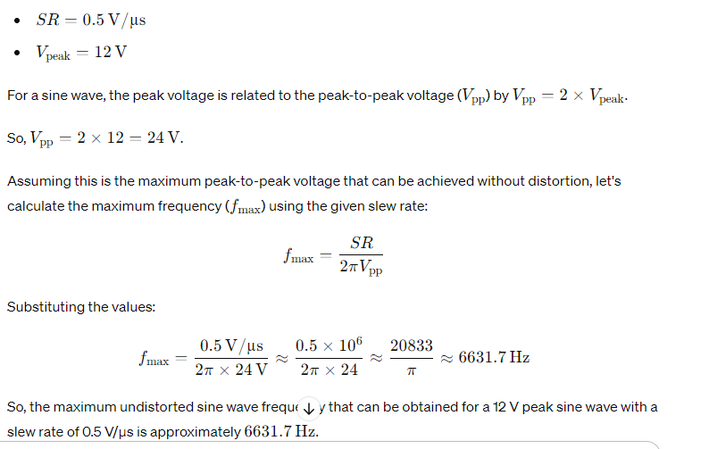

Justify - “Decreasing gain of an Opamp at high frequency is due to capacitive component” and name the major sources of component in the equivalent circuit of an Opamp.
- The decrease in gain of an Opamp at high frequencies is primarily due to the capacitive component, which introduces phase shift and reduces the Opamp's bandwidth.
- Major sources of components in the Opamp's equivalent circuit include input capacitance (Cin), parasitic capacitance at the collector (Cc), and the Miller capacitance (Cm) at the output node.

Consider an Opamp with PSR of 45 dB. When the Opamp is operated with a power supply, whose peak to peak supply voltage ripple is of 0.25V magnitude. Compute the effect of ripple at the output of Opamp.
List the disadvantages associated with differentiator circuit. Suggest a means to overcome these disadvantages.
In a current repeater circuit hfe = 100, R = 20KΩ, Vcc = 5V and V_{BE} =0.6V. Determine the value of Ic1, Ic2 and Ic3.

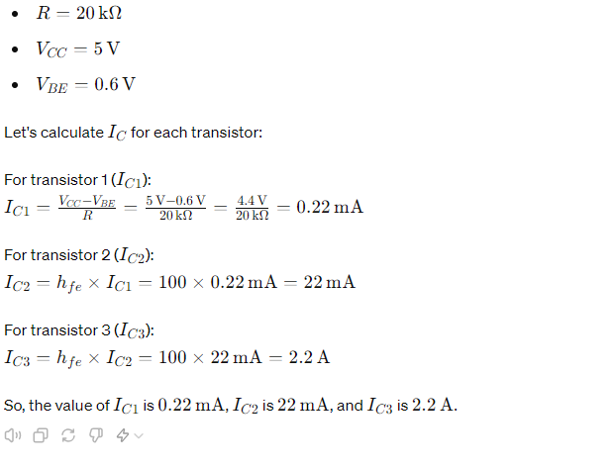
Give the transfer function of an Opamp with three break frequencies.
The transfer function of an operational amplifier (Opamp) with three break frequencies can be expressed as:

The transfer function of an Opamp with three break frequencies is:

H(s) = K / ((1 + s/ω1)(1 + s/ω2)(1 + s/ω3))

Where:

- H(s) is the transfer function
- K is the DC gain
- ω1, ω2, and ω3 are the break frequencies

This transfer function represents a third-order system with three poles, each corresponding to one of the break frequencies.
Given a bandpass filter with resonant frequency fr of 1000 Hz and a BW of 3000HZ, find it’s a) Lower cutoff frequency b) Higher cutoff frequency

BW of 3000HZ, find it’s a) Lower cutoff frequency b) Higher cutoff
Resonant frequency (fr) = 1000 Hz
Bandwidth (BW) = 3000 Hz

The lower cutoff frequency (fl) and higher cutoff frequency (fh) can be calculated using the following formulas:

fl = fr - (BW / 2)
fh = fr + (BW / 2)

Substituting the values, we get:

fl = 1000 - (3000 / 2) = 1000 - 1500 = -500 Hz (not possible, so take the absolute value) = 500 Hz

fh = 1000 + (3000 / 2) = 1000 + 1500 = 2500 Hz

So, the answers are:

a) Lower cutoff frequency (fl) = 500 Hz
b) Higher cutoff frequency (fh) = 2500 Hz

Assume that an opamp has I_{B1} = 400nA and I_{B2} = 300nA. Determine the input bias current I_{B} and the offset current IoS.

The input bias current (IB) is the average of the two input bias currents:

IB = (IB1 + IB2) / 2
= (400nA + 300nA) / 2
= 350nA

The offset current (IOS) is the difference between the two input bias currents:

IOS = |IB1 - IB2|
= |400nA - 300nA|
= 100nA

So, the input bias current (IB) is 350nA and the offset current (IOS) is 100nA.
Calculate the slew rate of op-amp from the output waveform given below?
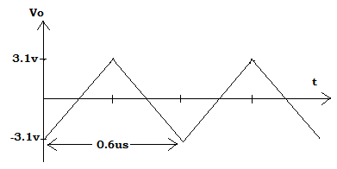
In a current repeater circuit hfe = 100, R = 20KΩ, Vcc = 5V and V_{BE} =0.6V. Determine the value of Ic1, Ic2 and Ic3.

Consider an Opamp with PSR of 90 dB. When the Opamp is operated with a power supply, whose peak to peak supply voltage ripple is of 0.5V magnitude. Compute the effect of ripple at the output of Opamp.
Let Iref = 10 mA , β =200 , No of transistor 5. Calculate the current flow through in Collector of 3rd & 5th Transistor if entire set of Transistor is connected in current mirror concept with all Bases are connected to each other . Assume Supply voltage is 10 V
Summarize the ideal characteristics of Operational amplifier
In note
Give the transfer function of an Opamp with three break frequencies.
The transfer function of an Opamp with three break frequencies is:

H(s) = K / ((1 + s/ω1)(1 + s/ω2)(1 + s/ω3))

Where:

- H(s) is the transfer function
- K is the DC gain
- ω1, ω2, and ω3 are the break frequencies

This transfer function represents a third-order system with three poles, each corresponding to one of the break frequencies.

Sketch the hysteresis curve of Schmitt trigger given VUT= 36mv and
VLT = -36mv.
Refer note
Differentiate the Integrator and Differentiator operations with the required diagram and functional equations
Differentiate the active filter and passive filter
Of course, here are three main points differentiating active and passive filters:

1. **Components Used**:
- **Active Filters**: Incorporate active components like operational amplifiers alongside passive components such as resistors, capacitors, and inductors.
- **Passive Filters**: Solely rely on passive components like resistors, capacitors, and inductors.

2. **Functionality**:
- **Active Filters**: Provide amplification and precise frequency response shaping capabilities due to the inclusion of active components.
- **Passive Filters**: Do not provide amplification and have limited frequency response shaping capabilities compared to active filters.

3. **Complexity and Cost**:
- **Active Filters**: Tend to be more complex and expensive due to the need for active components and power supplies.
- **Passive Filters**: Are simpler and more cost-effective as they only utilize passive components and do not require power supplies.

Estimate the Reference current value of Wilson & Widlar current Sources and Compare their effects on Iref & dependency on β
Illustrate the problems associated with differentiator circuit , suggest an appropriate solution for the same with necessary diagrams.
An ideal opamp doesnot draw current through its input terminal and differential input voltage is zero, but practically this is not the case. Show with necessary derivations that ideal non inverting amplifier results in the same gain as practical non inverting amplifier
An Opamp with more than one break frequencies is not stable, Describe the external compensation techniques to achieve stability
In a Schmitt trigger circuit R1 = 56K, R2 = 150Ω Vi = 1Vpp sine wave of frequency 50 Hz with supply voltages 0f ±15V and saturation voltages are ±13.5V. Determine the threshold voltage VUT and VLT, draw the input , output waveform and hysteresis curve. Also with a neat sketch explain the operation of Schmitt trigger.
Illustrate the process of signals varying when it is undergone to the following combinations.
a) Input component –R & Feedback component – C
b) Input component –C & Feedback component – R.
Assume: IC741 is used as active component & ideal. Derive for the cutoff frequency and gain for the given combinations
Given R1 = 10K, Rf = 100K and Cf = 10nf in a practical integrator circuit. Determine the lower frequency limit of integration and the output response for the inputs given fa = 2500Hz. a. Sine wave b. Square wave c. Step i/p . Also explain the working of an integrator in detail with necessary graph.
With neat diagram compute the output voltage of the amplifier which is said to be used in Medical industry &amp controlling Applications. Prefer the Amplifier that uses 3 individual op amp.
Consider the scenario where the output is equivalent to the absolute value of input signal V 0 = | Vi |. Identify the circuit and illustrate the operation with the required diagram and expressions.
Derive the transfer function of second order high pass butterworth filter. Design a first order high pass filter at a cutoff frequency of 2 KHZ with a pass band gain of 2.

11 | An Opamp with more than one break frequencies is not stable, Describe the external compensation techniques to achieve stability
12 | Calculate the effect of input bias current and input offset voltage on the output voltage of an Opamp, How can this be compensated, explain it with necessary equations.
13 | Select a suitable current mirror circuit so as to achieve very high output resistance. Interpret the relationship between output current and the reference current.
14 | In an integrator circuit gain is infinite, which is practically not possible, how do you deal with this issue, illustrate it with necessary diagrams.
15 | With neat diagram compute the output voltage of the amplifier which is said to be used in Medical industry & controlling Applications. Prefer the Amplifier that uses 3 individual op amp.
16 | An ideal opamp does not draw current through its input terminal and differential input voltage is zero, but practically this is not the case. Show with necessary derivations that ideal inverting amplifier results in the same gain as practical inverting amplifier.
17 | Examine the gain expression for Sallen- Key filter for the following considerations  a) Active filter with Unity Gain  b) Active Filter with Variable Gain  Map the gain value to the response on LPF and HPF
18 | An ideal opamp does not draw current through its input terminal and differential input voltage is zero, but practically this is not the case. Show with necessary derivations that ideal non inverting amplifier results in the same gain as practical non inverting amplifier.
19 | Describe the AC characteristics of the OPAMP with necessary diagrams
20 | Derive the transfer function of second order low pass Butterworth filter. Design a second order Butterworth low pass filter having upper cutoff frequency of 2 KHZ.

